Customer Churn Analysis & Prediction

Project Report

Introduction

Project Overview
Customer churn is one of the biggest challenges faced by subscription-based businesses. Churn refers to customers discontinuing or leaving a company’s service. Predicting customer churn helps businesses take proactive measures to improve customer retention and reduce revenue loss.
This project focuses on analyzing customer behavior using Machine Learning and Business Intelligence techniques to identify the key factors influencing churn. The project combines Python-based data analysis and predictive modeling with an interactive Power BI dashboard for business visualization.

1.2 Objective of the Project
The primary objectives of this project are:
- To analyze customer churn behavior using data analytics techniques
- To identify major factors responsible for customer churn
- To build a Machine Learning model capable of predicting churn
- To visualize churn trends using Power BI dashboards
- To generate actionable business recommendations for improving customer retention

1.3 Tools and Technologies Used
Category | Tools/Technologies
Programming Language | Python
Data Analysis | Pandas, NumPy
Data Visualization | Matplotlib, Seaborn
Machine Learning | Scikit-learn
Business Intelligence | Power BI
Dataset Format | CSV

Problem Statement
Customer retention is a critical challenge for modern businesses. Losing customers directly affects profitability, customer acquisition costs, and long-term growth.
- The purpose of this project is to:
- Analyze customer churn patterns
- Identify customers likely to churn
- Understand factors contributing to churn
- Build predictive models for churn detection
- Assist businesses in improving customer retention strategies

Dataset Overview

3.1 Dataset Description
The dataset contains customer information related to demographics, subscription behavior, customer interaction, and payment history.
The dataset was used to analyze customer behavior and predict whether a customer would churn or remain with the company.

3.2 Features / Columns Description
Feature | Description
CustomerID | Unique customer identifier
Age | Customer age
Gender | Customer gender
Tenure | Duration of customer relationship
Usage Frequency | Frequency of service usage
Support Calls | Number of support calls made
Payment Delay | Delay in customer payments
Subscription Type | Type of subscription plan
Contract Length | Duration of customer contract
Total Spend | Total customer spending
Last Interaction | Days since last interaction
Churn | Target variable indicating churn status

3.3 Dataset Size and Structure
- Total Rows: 440,833
- Total Columns: 12
- Numerical Columns: 9
- Categorical Columns: 3
The dataset contains both numerical and categorical data suitable for Machine Learning analysis.
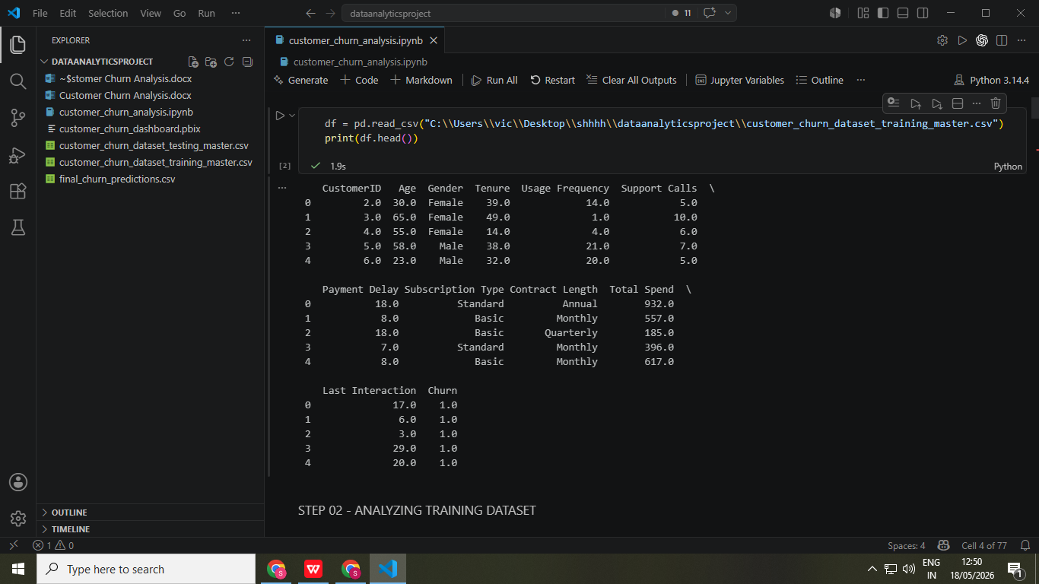

Project Workflow

4.1 Workflow Diagram
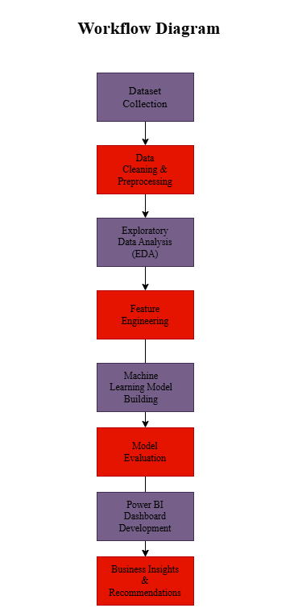

4.2 Project Pipeline Explanation

The project started with importing and understanding the dataset. Missing values and categorical variables were handled during preprocessing. Exploratory Data Analysis (EDA) was performed to identify churn patterns and behavioral trends.
A Logistic Regression model was then built to predict churn. Finally, Power BI was used to create an interactive dashboard for business analysis and reporting.

Data Cleaning and Preprocessing

5.1 Handling Missing Values
Missing values were identified using:
df.isnull().sum()
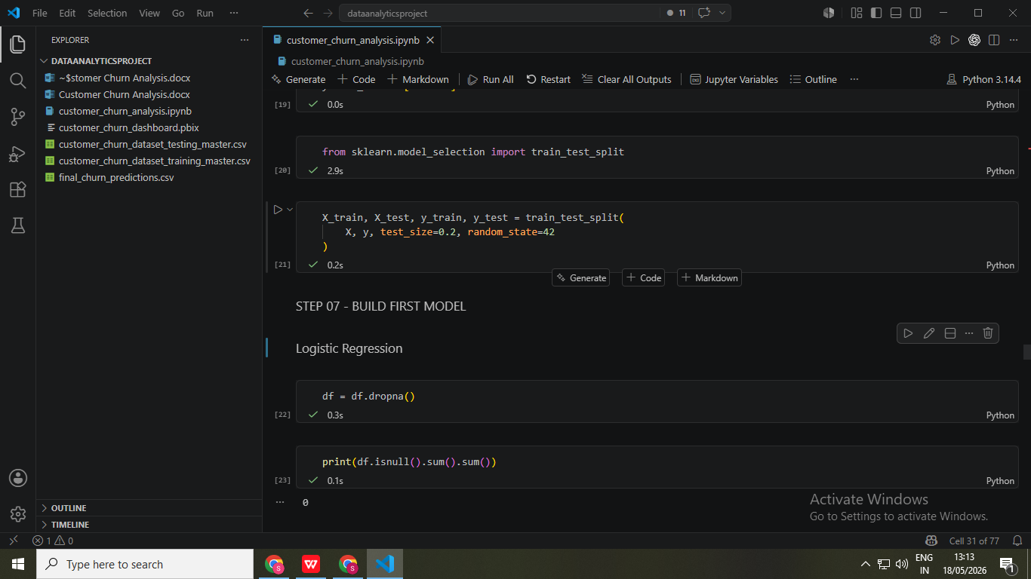
Rows containing missing values were removed using:

After cleaning, the dataset contained no null values.

5.2 Data Type Verification
The .info() function was used to verify:
- data types
- null counts
- memory usage
This helped ensure data consistency before model training.

5.3 Encoding Categorical Variables
Machine Learning models require numerical data. Therefore, categorical variables were converted into numerical format using one-hot encoding.
The following columns were encoded:
- Gender
- Subscription Type
- Contract Length
Encoding was performed using:
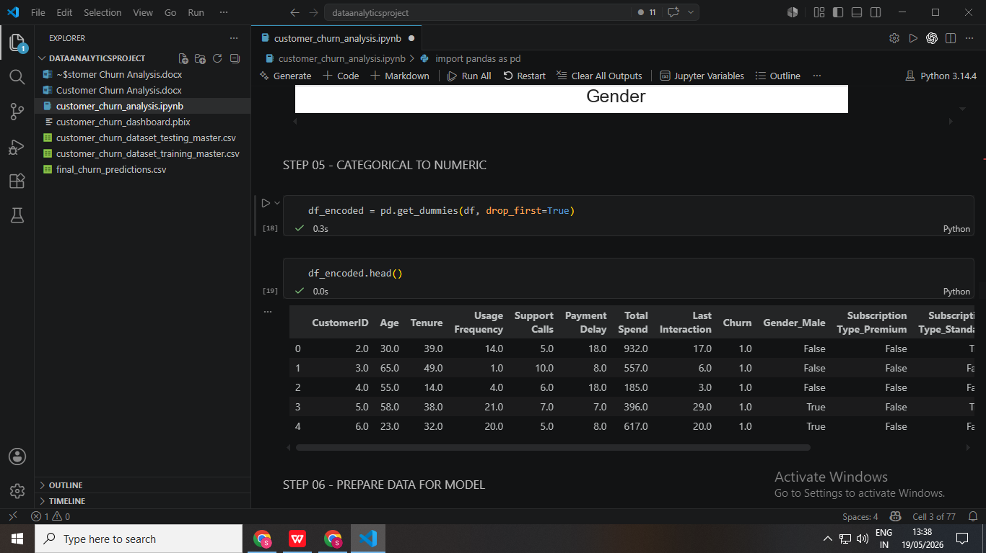

5.4 Feature Selection
The target variable selected was:
Churn
The remaining columns were used as input features for the model.

5.5 Train-Test Split
The dataset was divided into:
- 80% Training Data
- 20% Testing Data
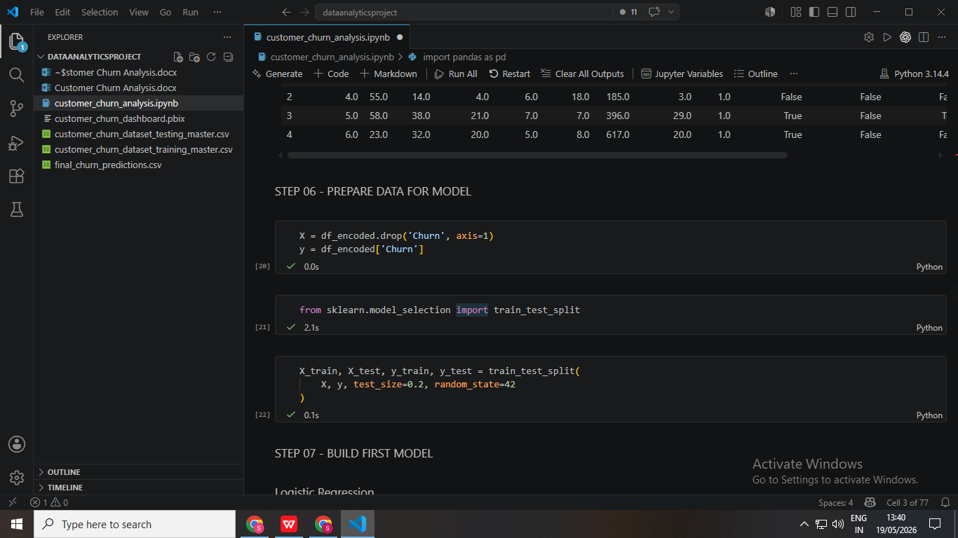
This ensured proper model evaluation on unseen data.

Exploratory Data Analysis (EDA)

6.1 Churn Distribution Analysis
The dataset showed a significant number of churned customers.
Churn Status | Count
Churned (1) | 249,999
Retained (0) | 190,833
This indicates a relatively high churn rate within the customer base.

6.2 Tenure vs Churn
Analysis showed that customers with shorter tenure periods were more likely to churn.
Customers who stayed longer with the company demonstrated greater loyalty and lower churn probability.
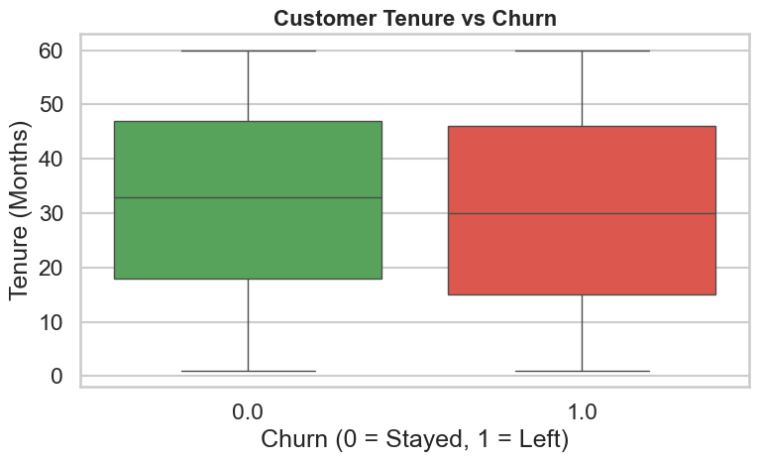

6.3 Support Calls vs Churn
Customers with higher support call frequency showed a greater tendency to churn.
This indicates that unresolved customer issues and dissatisfaction strongly influence churn behavior.
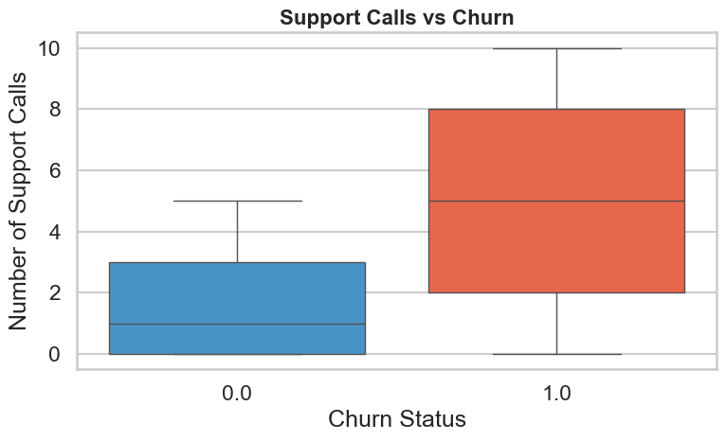

6.4 Payment Delay vs Churn
Customers with frequent payment delays exhibited significantly higher churn probability.
Delayed payments may indicate poor engagement or dissatisfaction with the service.
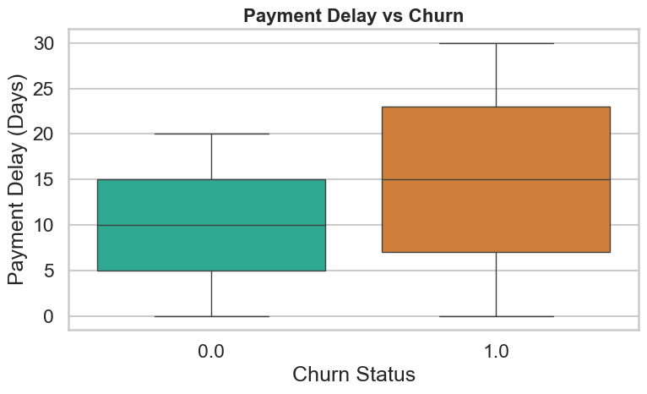

6.5 Contract Length vs Churn
Monthly contract customers displayed the highest churn rates compared to quarterly and annual subscribers.
Long-term contracts reduced customer churn due to higher commitment levels.
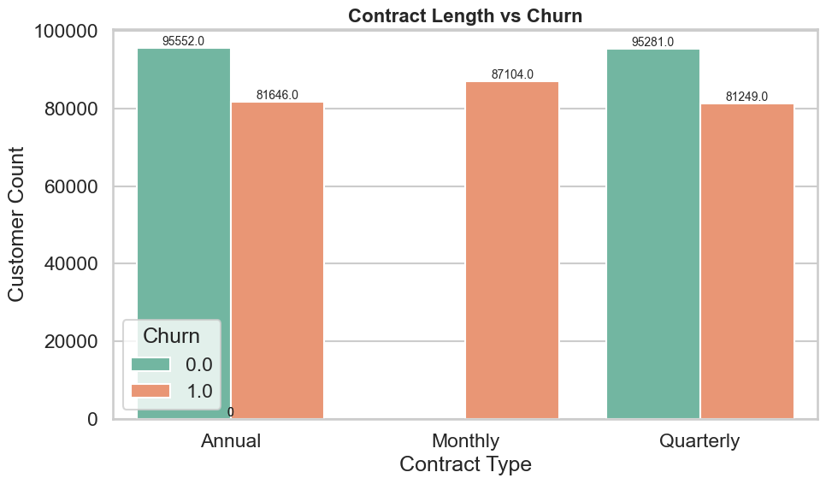

6.6 Subscription Type vs Churn
Different subscription plans demonstrated varying churn behavior.
Premium and Standard subscription users showed moderate churn tendencies.

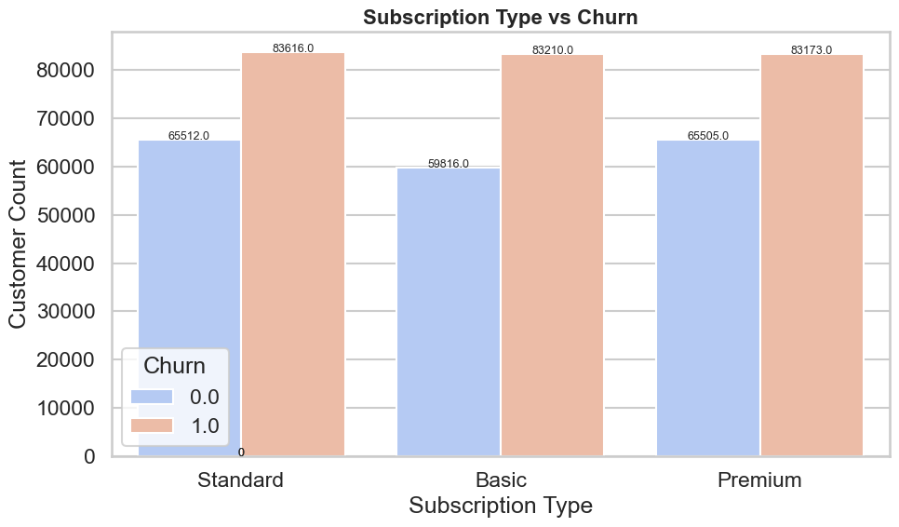

6.7 Gender vs Churn
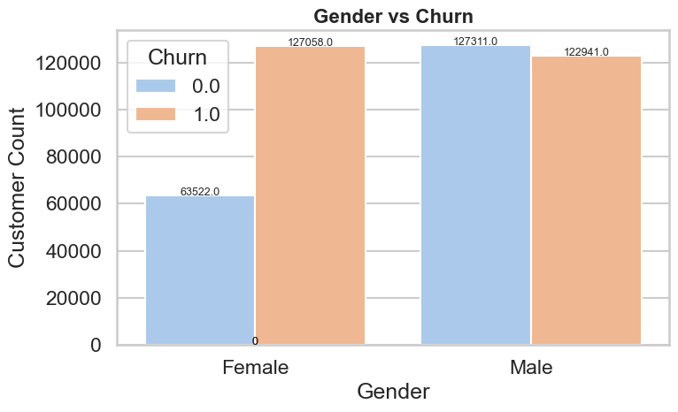
Gender-based analysis showed relatively balanced churn distribution with no major impact on churn behavior.

Machine Learning Model

7.1 Logistic Regression Overview
Logistic Regression is a supervised Machine Learning algorithm used for binary classification problems.
In this project, it was used to predict whether a customer would:
- Churn (1)
- Not Churn (0)

7.2 Model Training Process
The cleaned dataset was divided into training and testing sets.
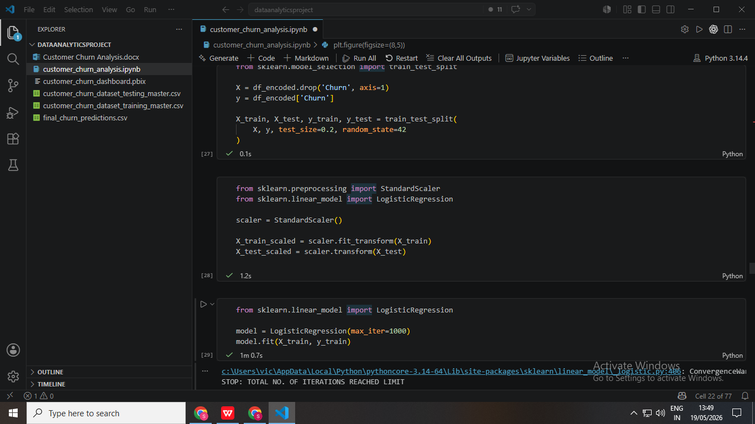
The Logistic Regression model was trained using:

The model learned relationships between customer behavior and churn probability.

7.3 Model Implementation
The model was implemented using Scikit-learn’s Logistic Regression algorithm.
Predictions were generated using:
y_pred = model.predict(X_test)

Model Evaluation

8.1 Confusion Matrix
The confusion matrix was used to evaluate prediction performance.
Results:
Actual / Predicted | Non-Churn | Churn
Non-Churn | 37119 | 944
Churn | 1561 | 48543

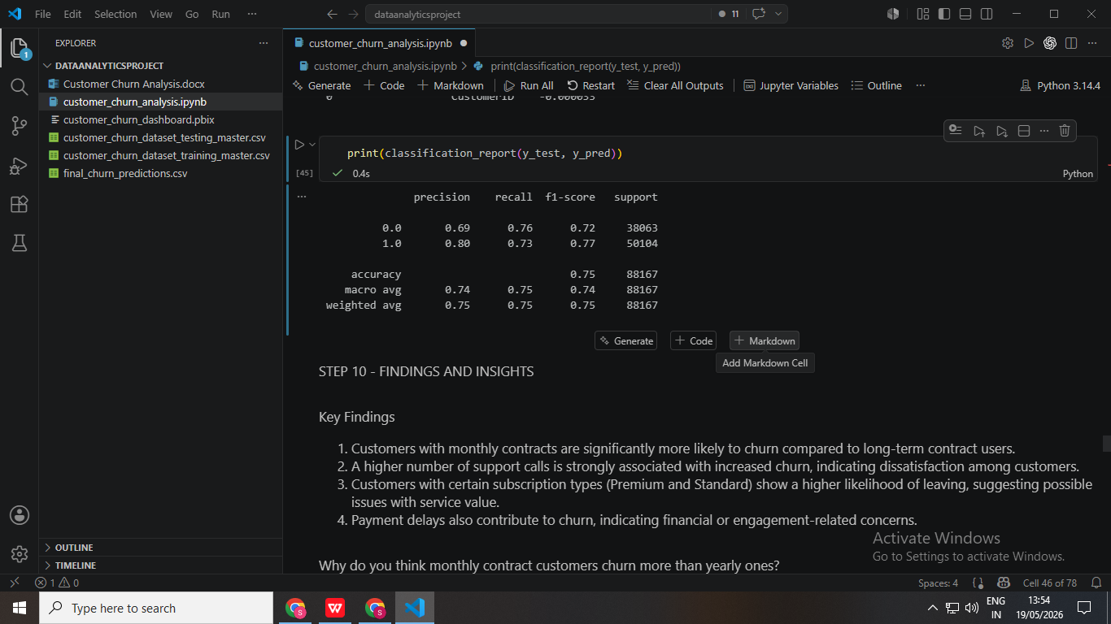

8.2 Classification Report
The classification report showed strong predictive performance.
Metric | Score
Precision | 97–98%
Recall | 97%
F1-score | 97%
Accuracy | 97%

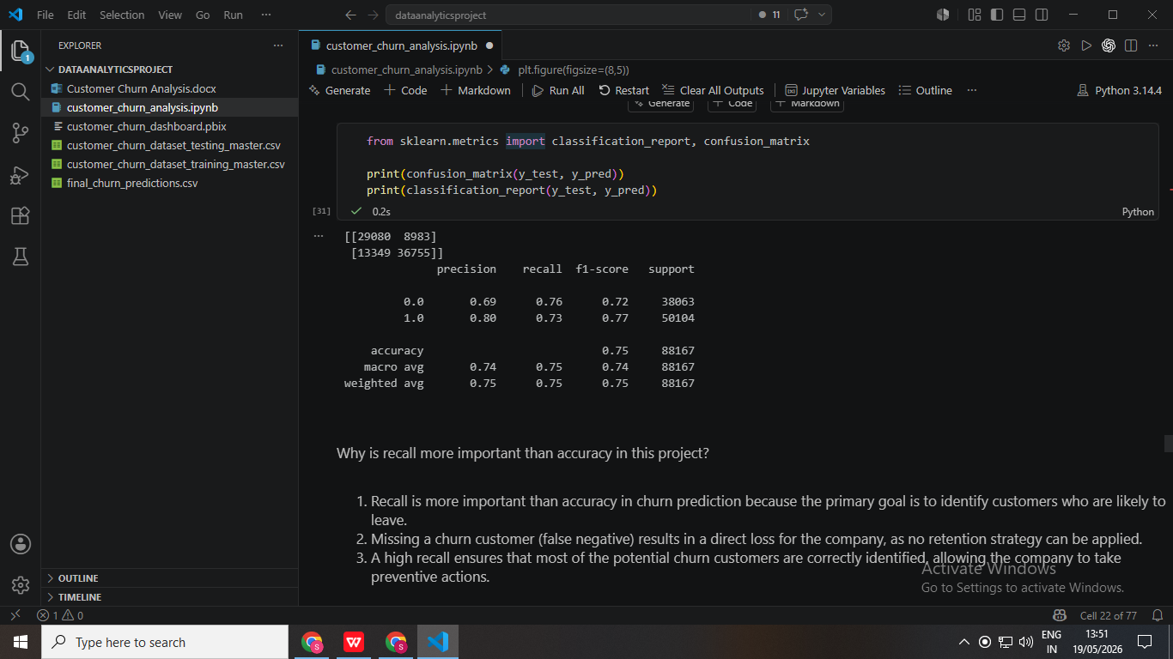

8.3 Accuracy, Precision, Recall, and F1-Score
The model achieved excellent classification performance.
High precision and recall indicate that the model effectively identifies churn customers while minimizing incorrect predictions.

8.4 Importance of Recall in Churn Prediction
Recall is especially important in churn prediction because missing churn customers can result in significant business losses.
A high recall ensures that most potential churn customers are correctly identified so businesses can apply retention strategies proactively.

Feature Importance Analysis

9.1 Top Churn Drivers
The most important features influencing churn were:
- Contract Length_Monthly
- Support Calls
- Subscription Type_Premium
- Subscription Type_Standard
- Payment Delay

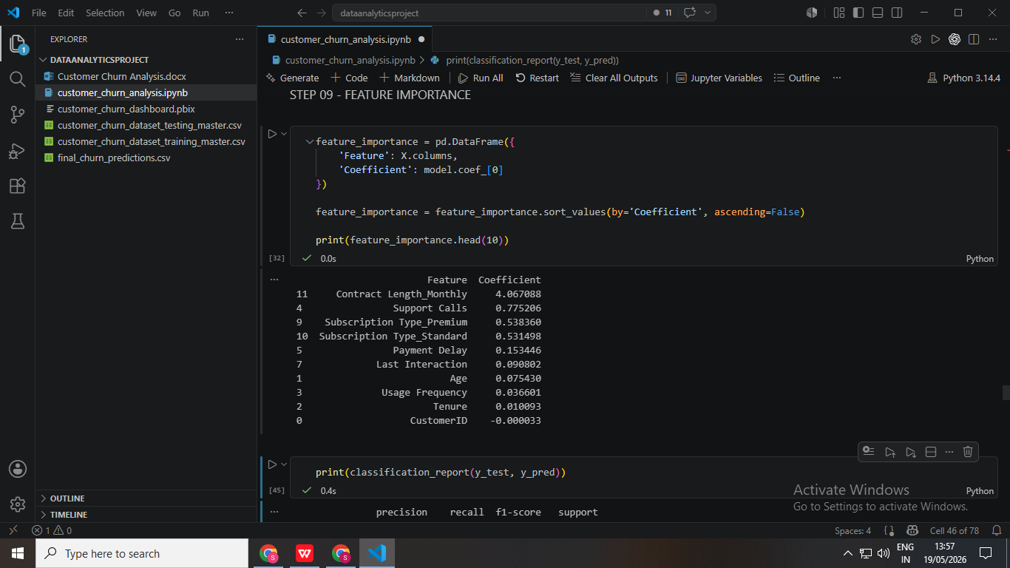

9.2 Interpretation of Feature Coefficients
Customers with monthly contracts showed the highest churn tendency due to lower commitment levels.
Support calls and payment delays were also strong indicators of dissatisfaction and churn risk.
Behavioral factors had greater influence on churn compared to demographic factors.

Power BI Dashboard

10.1 Dashboard Overview
An interactive Power BI dashboard was developed to visualize customer churn patterns and business insights.
The dashboard provides dynamic analysis using KPIs, filters, and visualizations.

10.2 KPI Cards
The dashboard includes key performance indicators such as:
- Total Customers
- Churn Rate
- Average Tenure
- Average Support Calls

10.3 Interactive Slicers
Interactive slicers were added for:
- Gender
- Contract Length
- Subscription Type
These slicers allow users to dynamically filter dashboard insights.

10.4 Dashboard Visualizations
The dashboard contains visualizations including:
- Churn by Contract Length
- Payment Delay Analysis
- Support Calls Analysis
- Subscription Type Analysis
- Gender Distribution
- Usage Frequency Analysis
- Tenure Analysis

10.5 Dashboard Screenshot
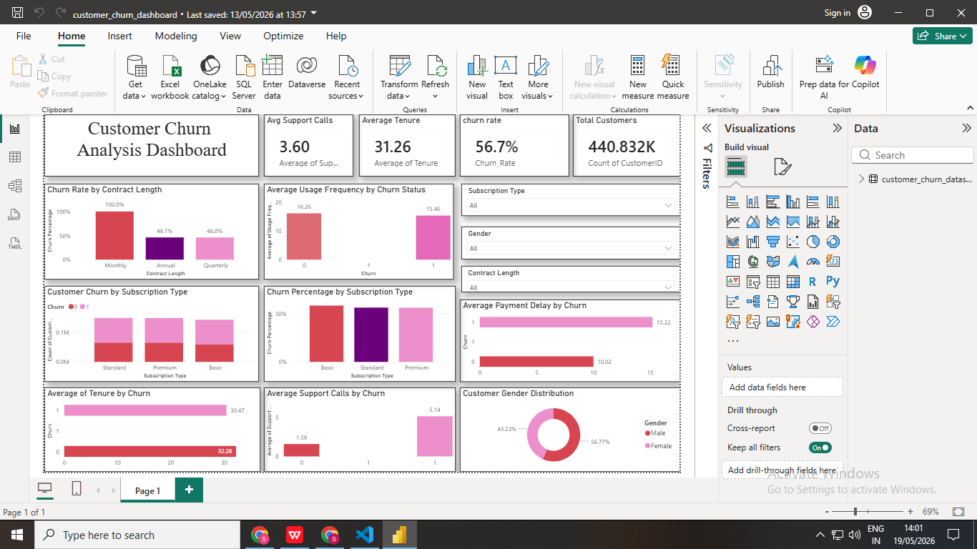

Key Findings and Insights
- Monthly contracts are the strongest driver of churn.
- Customers with more support calls are highly likely to churn.
- Payment delays significantly increase churn probability.
- Behavioral indicators are stronger predictors than demographic features.
- Long-term contract customers demonstrate higher retention rates.

Business Recommendations

Improve Customer Retention
- Promote annual subscription plans
- Offer discounts for long-term contracts

Enhance Customer Support
- Reduce issue resolution time
- Improve service quality

Monitor High-Risk Customers
- Identify customers with high support call frequency
- Provide personalized retention offers

Improve Payment Experience
- Send payment reminders
- Introduce flexible payment options

Increase Subscription Value
- Improve Premium and Standard plans
- Add customer-centric features

Conclusion
This project successfully combined Data Analytics, Machine Learning, and Business Intelligence techniques to analyze customer churn behavior.
The Logistic Regression model achieved strong predictive performance with approximately 97% accuracy and recall.
The Power BI dashboard transformed analytical insights into interactive business intelligence visualizations that support decision-making and customer retention strategies.

Future Improvements

Possible future enhancements include:
- Using advanced ML models such as XGBoost or Random Forest
- Deploying the model using Streamlit or Flask
- Integrating real-time customer churn prediction
- Connecting Power BI directly with live databases
- Adding predictive probability analysis

References / Libraries Used

Python Libraries
- Pandas
- NumPy
- Matplotlib
- Seaborn
- Scikit-learn

Tools
- Jupyter Notebook
- Visual Studio Code
- Power BI Desktop

